Attendee Survey

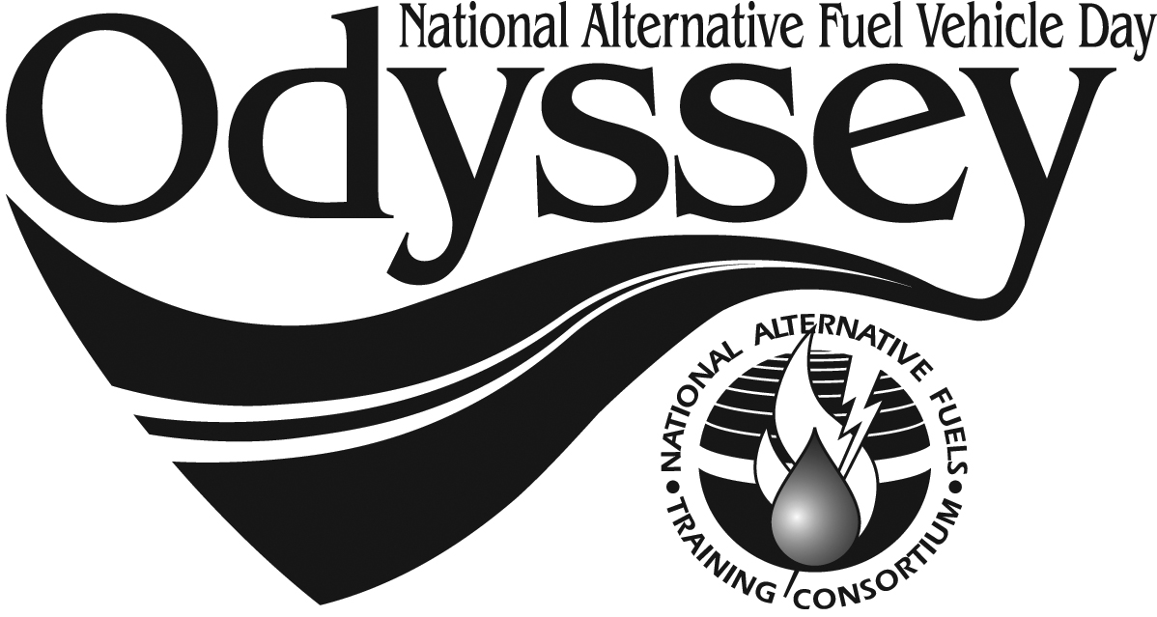

Event Location: __________________________________________________

Profession:

Elected Official
Governmental Agency
Educational Professional
Healthcare Professional
Environmental Org. Rep.
Fleet Manager
Automotive Technician
Auto Manufacturer
Auto Dealer
Student
Consumer
Other: _______________________

Have you or a household member ever personally owned an alternative fuel or advanced electric drive vehicles? Yes No
Did this event create changes in…
… Your interest in owning an AFV or AED vehicle. Yes No
… Your confidence in using AFV or AED vehicles Yes No
… Your enthusiasm for supporting AFV or AED vehicles Yes No

Would you include AFV or AED vehicles in test drives before making an automobile purchase?
Before today: Yes No
After today: Yes No

Would you consider purchasing an AFV or AED vehicle for personal use?
Before today: Yes No
After today: Yes No

Will your support expanding the availability of local alternative fuel vehicle options?
Before today: Yes No
After today: Yes No

At this event did you learn anything about:
Where to purchase AFV or AED vehicles in your area.
Types of AFV or AED vehicles available in your area.
What types of alternative fuels are available in your area.
Governmental incentives for purchasing AFV or AED vehicles.
How AFV or AED vehicles can save money in operational costs.
How AFV or AED vehicles can reduce air pollution.
How using AFV or AED vehicles can reduce our dependence on foreign oil.
Benefits of various AFV or AED vehicles.
Safety factors in operating AFV or AED vehicles.
Where to receive training in AFV or AED automotive technologies.

How did you learn about National AFV Day Odyssey? Please check all that apply.

Local Event Website
National Website
Postcard
Radio
Newspaper
TV
Social Media
(facebook, twitter, etc.)
Industry Newsletter
Presentation at Meeting
Invitation to Present
Email
Poster or Sign

Comments: _____________________________________________________
_______________________________________________________________
_______________________________________________________________
_______________________________________________________________
_______________________________________________________________
_______________________________________________________________
_______________________________________________________________
_______________________________________________________________

Thank you for attending today’s event. For more information about National AFV Day Odyssey, visit www.afvdayodyssey.org.

