National AFV Day Odyssey 2017
Thunderclap Campaign
What is Thunderclap?
Think of Thunderclap as a social media flash mob, or a massive scheduled social media post.
Supporters can sign up to have a specific Odyssey message published to their Facebook and/or Twitter account on April 20th. Thunderclap is similar to crowdfunding, but uses social currency instead of money. Your social media followers (or anyone else) can “donate” a Tweet or Facebook post to help spread the word. Read more.
Why join Thunderclap?
A few scattered Tweets or Facebook posts get lost in the noise of social media. When your audience shares the same message at the same time, their friends and followers are more likely to take notice. This means that your reach extends beyond Odyssey’s existing network, growing our audiences and exposing Odyssey’s message to a broader community
Thunderclap makes it so Odyssey fans don’t need to remember to post a message to their social media account at a specific time in support of the event. The Thunderclap campaign allows Odyssey and Odyssey events to lock in reach and support numbers ahead of time.
Thunderclap has been used by AmeriCorps, Stand Up to Cancer, People Magazine, and Major League Baseball to coordinate social media campaigns.
Is it secure?
From the Thunderclap website:
Thunderclap takes users' privacy very seriously.
When you sign into Thunderclap with a social media account to support a campaign, you’re allowing Thunderclap to share a single message on your behalf. This is only the case when you click the button on the campaign page to support with Twitter, Facebook, or Tumblr. After the campaign is complete, we won’t post any additional messages.
Thunderclap supporters and organizers include President Barack Obama, the United Nations, the U.S. Department of State, and countless other public figures, organizations, and government agencies.
We use the latest encryption standard TLS 1.2 to secure our data.
You can review our full privacy policy here.

How can I participate?
First, sign up to support Odyssey’s Thunderclap Campaign here. You can support Odyssey through Facebook, Twitter, and Tumblr, or just one social media account.
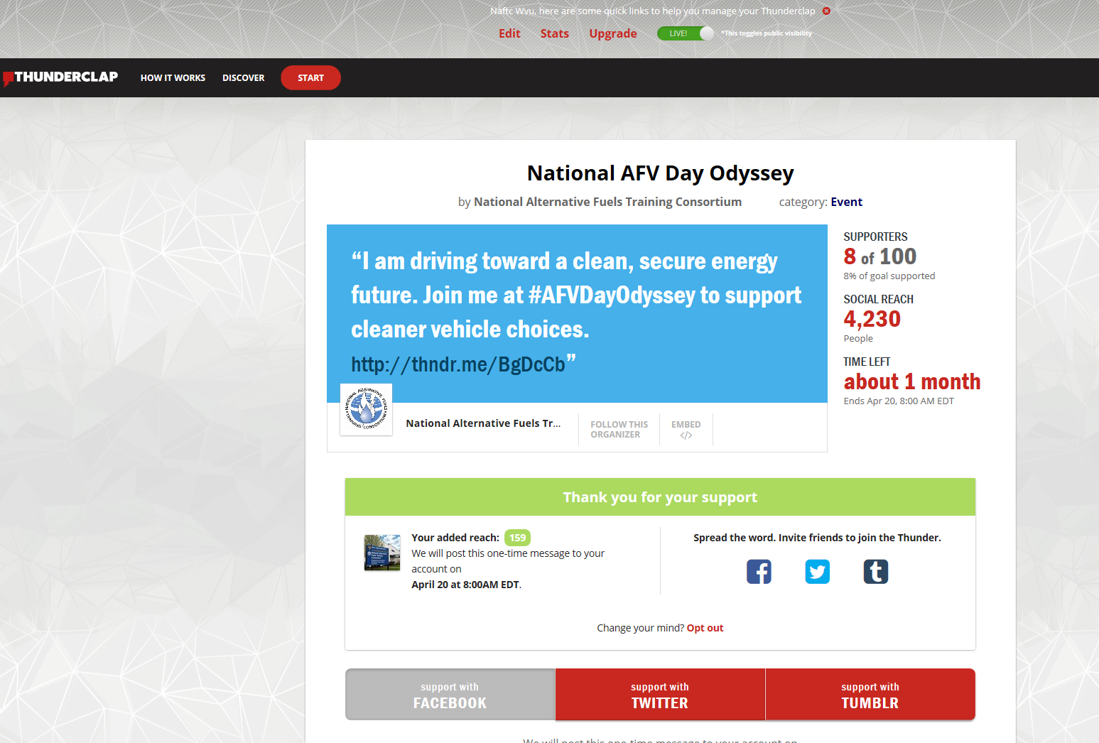
Click these links to join.

Then share the campaign with your followers.
Once you have joined the campaign, you can share the campaign from the same webpage.
Click these links to share.
Or, you might post something like these examples to your social media accounts:
[Organization Name] is hosting an #AFVDayOdyssey event. Support Odyssey with an update or tweet through @Thunderclap. http://buff.ly/2njxRVm
To promote #AFVDayOdyssey 2017, organizers partnered with #Thunderclap. Click to learn how to donate a status update or tweet in support of cleaner transportation options. http://buff.ly/2njxRVm
Please help boost our campaign to promote the use of alternative fuel vehicles by clicking the link. [Organization Name] is hosting an Odyssey event this year to promote cleaner transportation choices. http://buff.ly/2njxRVm
Help us spread the word about #AFVDayOdyssey by clicking through to our @ThunderclapIt campaign.
Finally, follow up with your social media fans and others who support your organization. The Thunderclap website has some great ideas to encourage participation. Read more.

The more people who sign up through the Thunderclap campaign, the greater number of people Odyssey message of the importance of cleaner transportation options will reach. Thank you for joining us as we drive toward a clean, secure energy future!

